SAMARUVA MEATS BILLING SYSTEM

SECTION A

SELECTION, INVESTIGATION AND ANALYSIS

PROBLEM DEFINATION

Samaruva meats is a butcher that is located in Budiriro 1, Harare. It was opened in 2016 on the twentieth of March. The butchery has three workers. During the first period they used to receive few customers but as time went on the customers increased. They currently receive about sixty customers per day. It was because the manager of the butcher had a good relationship with the customers. When they buy and sell meat, they record all the incomes and outcomes in books and files. The butchery uses the manual method to store and save their information. The manual method is very slow and the books and files can be easily destroyed by water and can be torn by the workers by mistakes. Another problem that the system is facing due to the use of manual method is that for instance if they want certain records from a specific period of time it takes a lot time to find the files or books which will delay the process. The current system is time consuming and it is very tiring to the workers. It is also prone to errors since humans cannot perform activities perfectly than the computers do. As the system analyst l would like to change the current manual system to a computerized system. The manual procurement contains a lot of tasks that are repeated for each procurement event including negotiation phone calls with the supplier and creating similar documents multiple times and so on.

INVESTIGATION OF THE CURRENT SYSTEM

DATA ANALYSIS

ZERO LEVEL DATAFLOW DIAGRAM

A zero level dataflow diagram is the basic form that aims to show how the entire system works. It demonstrates the interactions between the system process and the externals entities.

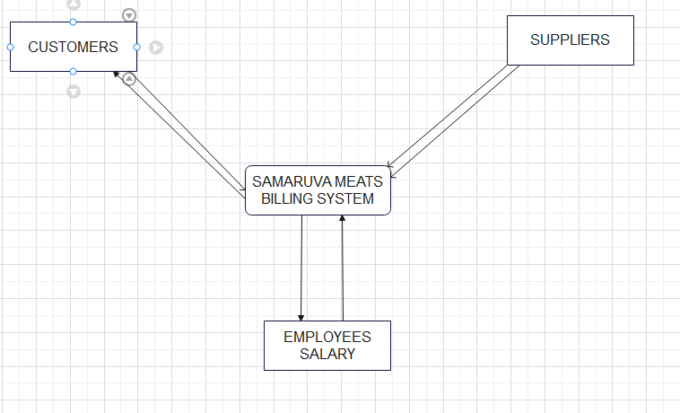

FIRST LEVEL DATA FLOW DIAGRAM

It gives a full overview of the whole Samaruva Meats system. Some of the processes that occur in the system are broken down into sub-processes such as printing out a customer receipt and adding displaying the electricity bill.

FLOWCHART

The below flowchart shows the discount taken off depending on the number of kilograms bought by a specific customer in the Samaruva Meats butcher.

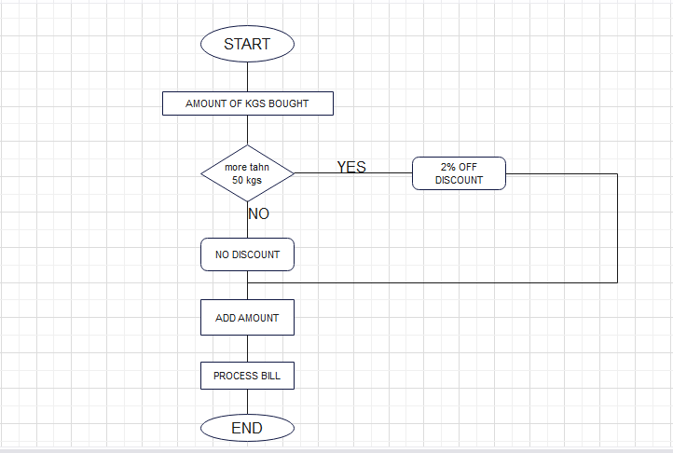

ENTITY RELATIONSHIP DIAGRAM

The below shows the entity relationship diagram for the Samaruva Meats Billing System.

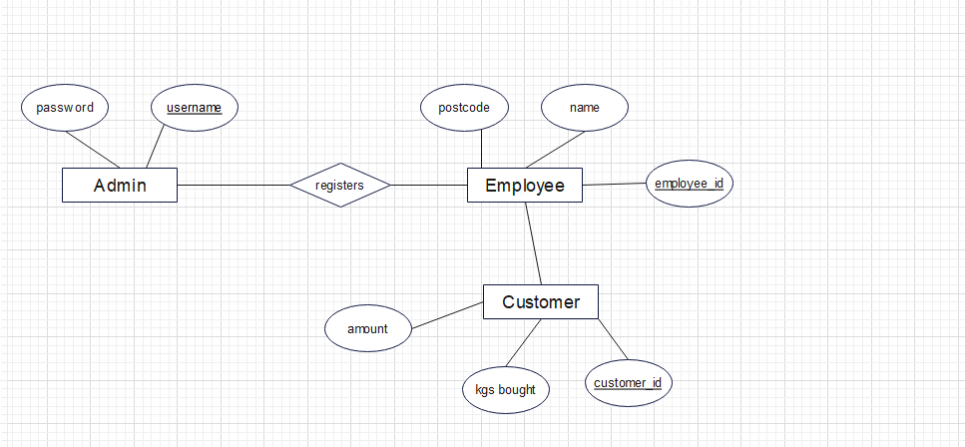

RESEARCH INSTRUMENTS

As the system analyst l carried out an investigation on the current system used at Samaruva Meats using a paper file for recording. The system analyst used the following data collection methods:

1. Interviews
2. Observation
3. Questionnaire
4. Record and inspection

**INTERVIEWS**

An interview is a face-to-face communication between two or more people that is done in order to collect information. In other terms it is a conversation between the interviewer and interviewee whereby the interviewer asks questions from the interviewee in this case the system analyst was the interviewer. The system analyst visited the butcher and asked the manager and the employees a few questions concerning their current system.

ADVANTAGES OF INTERVIEW

-The system analyst was able to ask for clarification on some points that were not clear.

-The system analyst was able to get better responses rate than mailed questions since they understand the body language and facial expressions of the research respondents.

-The system analyst was able to explain and explore research subject’s behavior.

DISADVANTAGES OF INTERVIEWS

-It is impossible to remain anonymous on the part of the interviewee.

-it is expensive since the system analyst has to travel to the interview venue.

-Good interview techniques are required as failure may lead to disappointments.

**OBSERVATION**

It involves viewing the actual system in operation by researcher. The searcher can even take part in operating the system. This is a data collection method that the system analyst also took into consideration where she went to the Samaruva Meats butcher to observe the behavior of the customers and employees without them noticing that they are being observed.

ADVANTAGES OF OBSERVATIONS

-Areas of interest can be observed.

-The analyst obtains reliable data since firsthand information is collected

-Accurate information can be obtained since the system analyst can take part in operating the system.

DISADVANTAGES

-if workers perform tasks that violate standard procedures, they may not do this when being watched

-some of activities may be interrupted by the researcher

-people work differently if they feel there being observed therefore the information is inaccurate

**QUSTIONNAIRES**

They are documents with carefully crafted questions to be answered by the respondent by filling on the spaces provided. The system analyst created a list of questions to ask the employees, managers and customers about the butcher.

ADVANTAGES

-Gives guarantees confidential of information thereby encouraging respondents to give accurate information

-respondents can fill questionnaires at their own pace

DISADVANTAGES

-Some of the questionnaires were not returned at all.

-it is difficult to analyze information collected using questionnaires

-it is difficult to prepare a good questionnaire

-they are expensive to use if the postal system is used

**THE FOLLOWING ARE THE PROBLEMS THAT WERE DISCOVERED FROM**

**THE CURRENT SYSTEM:**

-Information that is written in books or files can be easily destroyed by natural hazards such as fire.

- A manual system is very inefficient as record search takes a lot of time.

-The system is very tiresome as record system is done manually.

-The manual system is less secure and can be easily accessed by intruders.

**FEASIBILITY STUDY**

This is an evaluation that the system analyst did to determine if it is possible to construct a new system or just modification of the existing one.

Feasibility study can be measured by making the following consideration:

ECONOMIC FEASIBILITY

The new system is worth the expenses since it will enhance the butcher’s day to day operations. The system analyst was determining whether the new system will outweigh the estimated cost involved in developing, purchasing, installing and maintenance of the new system. The organization might have to increase its sales and get a loan in order to suit the system.

|  |  |
| --- | --- |
| ACTIVITY | ESTIMATED COST |
| Software development | $1000 |
| Employee Training | $500 |
| Hardware installation | $750 |
| Total | $2250 |

The estimated amount is worth to suit all the requirements needed for the system economically.

TECHNICAL FEASIBILITY

Technical feasibility determines if the Samaruva meats butcher can obtain software, equipment and personal to develop, install and operate the system and even maintain it. For the new system to perform efficiently it has to be technologically developed. The butcher is to buy new machines such as tills, barcode readers and computers because the organization does not have the technological devices.

LEGAL FEASIBILITY

The new system can legally fit into the society. It does not contain any illegal activities that can lead the government into closing the butcher. As the system analyst l can reassure you that it can suit all the legal formalities of any butcher.

OPERATIONAL FEASIBILITY

This is an operational study that the system analyst carried out in order to determine whether the current work practices are adequate enough to support the system. The result of the study is that the workers will need to be trained on how the new machines will be used. The new system will help the users to take advantage of opportunities identified during the scope definitions and how well it will solve the problems identified by the system analyst.

SCHEDULE FEASIBILITY

This is an estimation on how long the proposed system will take to develop and if it can be completed in a due given period of time.

The development of the system will meet the delivery deadline of seven months provided by the Samaruva Meats billing team.

The following is a breakdown of the activities on how they are to be carried out

|  |  |
| --- | --- |
| JANUARY – FEBRUARY | Problem definition, data collection, system analysis, interpretation of collected data |
| MARCH – APRIL | System design |
| MAY- JUNE | System debugging and testing if the system is reliable |
| JULY | Submission of the new system |

Therefore, as the system analyst with the help of the above feasibility study the system will fit into the society and is affordable. The system will take at least seven months to be submitted according to the system analyst research.

According to the system analyst research from the feasibility study carried out I have concluded to adjust and proceed with the project that l am carrying out.

**REQUIREMENTS SPECIFICATIN**

USER REQUIREMENTS

The proposed system should be capable of solving the identified problems so that the users of the system will not have any problems while using it.

The requirements of the users include:

-Accurate data

-Logins of the system should be fast and easy

-The system must not be tiresome to the users

-The system must be able to run on whatever device used

THE HARDWARE AND SOFTWARE REQUIREMENTS ARE AS FOLLOWS:

HARDWARE REQUIREMENTS

|  |  |
| --- | --- |
| KEYBOARDS | To type in details such as suppliers’ details |
| PROCESSOR | Control the transmission of data from input devices to the main memory |
| MOUSE | Control a cursor in graphical interface for pointing and selecting files |
| PRINTER | It accepts text and graphic output from a computer and transfers the information to paper |
| MONITOR | To display inputted information |
| USB FLASH | For the transfer of information from one person to another |

SOFTWARE REQUIREMENTS

|  |  |
| --- | --- |
| Vb.net | Creating interfaces for the system |
| MS access database | To connect with vb.net in order to save files |
| Avast anti-virus | To protect the computers from viruses |
| Microsoft word | Recording information such as employees details |
|  |  |

**AIMS AND OBJECTIVES**

AIMS

-To design a system that is fast in processing data and that is not tiresome to the employees.

-To develop a computerized system for the Samaruva Meats Billing

-To develop an easy back-up system

-To develop a system that is more secure

OBJECTIVES

-To develop a system that is easy to debug.

-To develop a system that will help in the running of the day-to-day bills of the Samaruva Meats Billing accurately and automatically.

-To have a system that will help in reducing unauthorized criminal cases such as hacking and pharming.

**EVIDENCE THAT THE RESEARCH HAS BEEN MADE**

QUESTIONNAIRE FOR THE SAMARUVA MEATS MANAGER

My name is Tinashe Magadzire a computer scientist student at Belvedere Technical Teachers College. I would like you to please fill up the questions below. The answers that you’ll provide will be a help to the research that the system analyst has been carrying out on the Samaruva Billing System.

1. When was your butcher opened?

…………………………………………………………………………..

1. How do you record your inputs and outputs?

……………………………………………………………………………………

1. Are you happy with your current system if not why?

…………………………………………………………………………………………………………….

1. Are the customers satisfied with your service?

…………………………………………………………………………………………………………….

|  |  |  |
| --- | --- | --- |
| QUESTIONS | YES | NO |
| 1. Is the current system fast in recording information? |  |  |
| 1. Is it easy to back-up your data? |  |  |
| 1. Is it easy to debug? |  |  |
| 1. Are the customers served on time? |  |  |
| 1. Is it easy to identify the profits and losses on the bills that the butcher makes |  |  |
| 10. Is it easy to find information about previous years? |  |  |

INTERVIEW FOR THE SAMARUVA MEATS MANAGER

On the 11th April 2021 the system analyst visited the Samaruva Meats butcher in Budiriro and

Met with the manager and one of the employees.

The document below shows the information that l obtained from the interview that l carried out.

1. When was the butcher opened?

…………………………………………………………………………………………

1. What storage facilities do you use to store information

……………………………………………………………..

1. Do you think the customers are pleased on how you’re running your butcher?

………………………………………………………………………………………………………………..

1. As the manager are you satisfied on how your current system operate?

……………………………………………………………………………………………………..

1. Approximately how many customers do you serve per day

…………………………………………………………………………………………………

OBSERVATIONS BY THE SYSTEM ANALYST

The system analyst made a visit to the Samaruva Meats butcherer and made some observations which include the butcher gets a lot of customers around evening times because it is a period where most of the people get off jobs. There are very slow when it comes to serving customers. The manual system delays a lot of things for the employees since everything has to be written which is very tiring and time consuming.

**The books that the Samaruva Meats uses to store their information and data.**

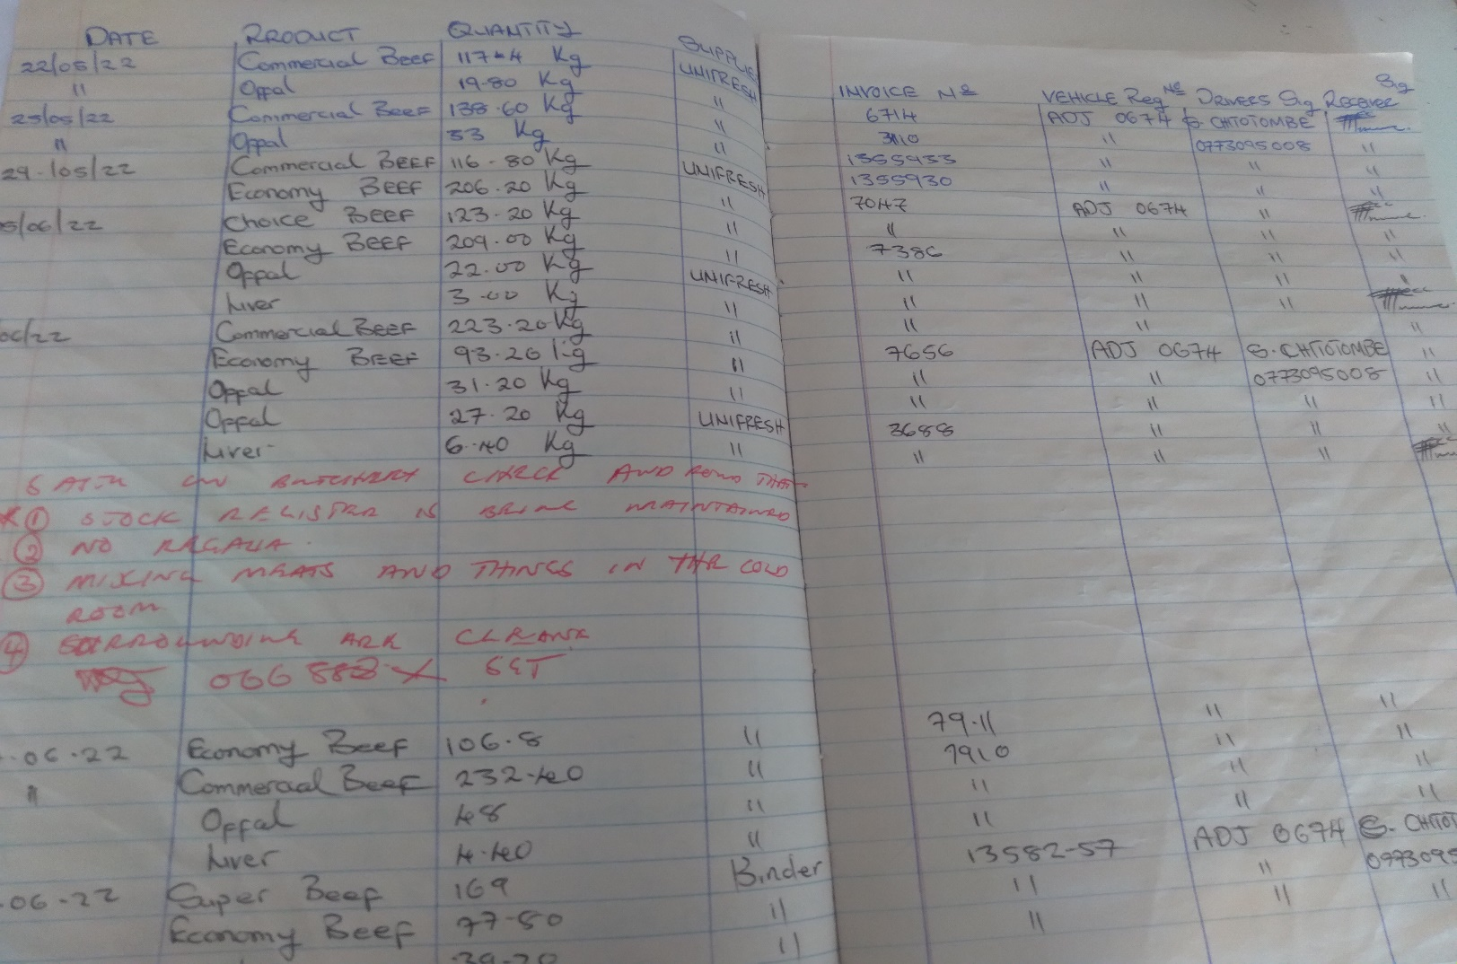

The above picture shows where the Samaruva Meats manager records the meat brought in by supplies and the invoices issued to them.

SECTION B

**DESIGN**

CONSISDERATION OF ALTERNATIVE METHODS

The system analyst came out with three different alternatives therefore she provided the advantages and disadvantages of each alternative.

The alternatives include an off-the-shelf software, designing a bespoke machine and making an in-house development.

**BESPOKE /TAILOR MADE SOFTWARE**

It is a software that is customized for a specific purpose. This is designed for a specific customer who goes to software developers with his or her specific needs or problems and a software will be developed for the customer basing on his or her specific need. It is designed for a specific organization. The Samaruva Meats billing might consider the tailor-made software because of the below advantages:

ADVANTAGES OF A BESPOKE SOFTWARE

- It has been specifically designed for your particular requirements and can be tailored to fit in exactly with the way that your business or organization wishes to operate.

- Users will usually find it easier and more intuitive to use as it should not contain unnecessary or superfluous facilities and should operate in the way that they are used to working.

- It is much more flexible than packaged software and can be modified and changed over time as your requirements and business practices change.

DISADVANTAGES OF A BESPOKE MADE SOFTWARE

* It can be difficult to get support for bespoke software, unless the developers themselves offer support services which is very expensive.
* If you pick the wrong developer you could end up with an application that is unstable, unreliable and full of bugs it is expensive to hire a professional software developer.
* The use of professionally developed bespoke software applications can give you a significant business advantage over your competition.
* To avoid this problem, make sure you choose a developer who provides you with the source code If you do not have the source code you are dangerously exposed and are wholly dependent upon the developer's continuing existence and good will.

**OFF-THE-SHELF SOFTWARE**

This is an already made software that is used by various organizations. This software is designed for a specific purpose for example Microsoft Word and Microsoft Publisher.

ADVANTAGES OF AN OFF-THE-SHELF SOFTWARE

* Since it already made it is cheaper and easy to used
* It is easy to get support and literature is usually widely available as there are many other users using exactly the same software.
* It is easy to share files produced by the software with others as chances are they also have the software available to open the file.
* You don't have to dedicate any of your time to the development process.
* Updates usually included and can offer you more functionality than you need

DISADVANTAGES OF AN OFF-THE-SHELF SOFTWARE

* Users have to compromise on the available resources since it is designed for a lot of organizations and many people use it.
* The software can be highly complex and will usually include large sections that you will never use.
* As the same system can be bought by your competitors it is very difficult to gain any competitive advantage from its use.

IN-HOUSE DEVELOPMENT SOFTWARE

This system is developed by the organization that is to use the system. The organization does not outsource the software to other companies.

ADVANTAGES

* It is designed to meet the needs the company.
* One does not have to wait for it to be put on the market therefore it saves time.
* It can be put to use before it is done if partial functionality adds to the organization.

DISADVANTAGES OF AN IN-HOUSE DEVELOPMENT SYSTEM

* It is very expensive to develop the system.
* It takes a lot of time to develop and to implement the system software.

JUSTIFICATION OF THE PROPOSED SYSTEM

The system analyst proposed the use of the off the shelf system. An off the shelf software is usually the cheapest way to purchase a new software solution. This is because it is pre-made product created for the mass-market. As it has already been developed and is purchased multiple times the cost is therefore reduced as it is spread over many users.

INPUT DESIGN

DATA CAPTURE FORMS

ELECTRICITY BILL INPUT FORM

UNIT PRICE

UNIT CONSUMED

TOTAL BILL

RESET

INVOICE

EMPLOYEE SALARY INPUT DESIGN FORM2

Employee ID

First name

Surname

Address

Post Code

Salary

RESET

DELETE

UPDATE

SAVE DATA

DATA STRUCTURES

It is data organization, management and storage format that enables efficient access and modification. The following are the data structures of the Samaruva Meats billing system

Fig1LOGIN FORM

|  |  |  |  |
| --- | --- | --- | --- |
| FIELD NAME | DATA TYPE | DISCRIPTION | VALIDATION RULE |
| USERNAME | SHORT TEXT | The name of the current user | 35 CHARACTERS |
| PASSWORD | SHORT TEXT | Password to get into the system | 50 CHARACTERS |

Fig2EMPLOYEE SALARY FORM

|  |  |  |
| --- | --- | --- |
| FIELD NAME | DATA TYPE | VALIDATION RULES |
| EMPLOYEE ID | SHORT TEXT | 35 CHARACTERS |
| FIRSTNAME | LONG TEXT | 50 CHARACTERS |
| SURNAME | SHORT TEXT | 35 CHARACTERS |
| ADDRESS | AUTONUMBER |  |
| POSTCODE | SHORT TEXT | 50 CHARACTERS |
| SALARY | AUTONUMBER |  |

Fig 3 ELECTRICITY BILL FORM

|  |  |  |
| --- | --- | --- |
| FIELD NAME | DATA TYPE | DESCRIPTION |
| UNIT PRICE | AUTONUMBER | Amount charged per each unit of electricity |
| UNIT CONSUMED | AUTONUMBER | Amount of electricity used by the organization |
| TOTAL BILL | AUTONUMBER | Unit price * unit consumed |

SCREEN LAYOUTS

SCREEN LAYOUT FOR THE EMPLOYEE SALARY FORM

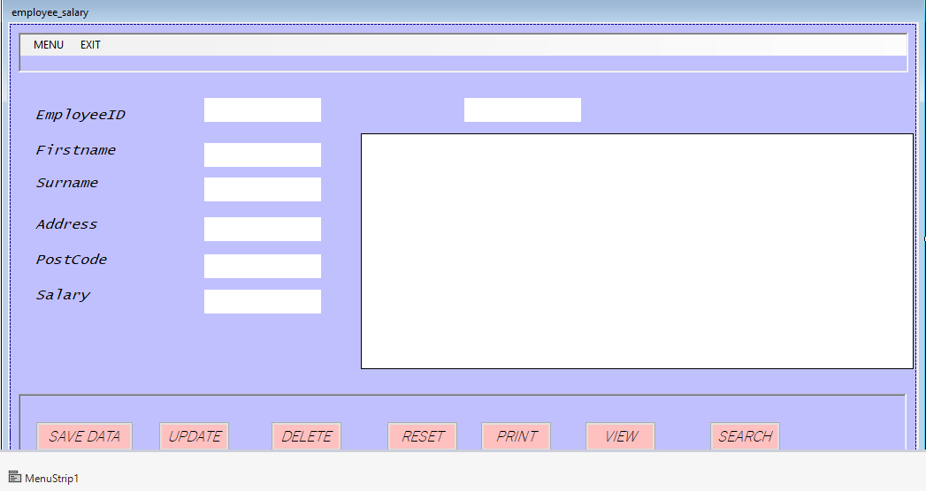

SCREEN LAYOUT FOR THE EMPLOYEES’ DETAILS FORM

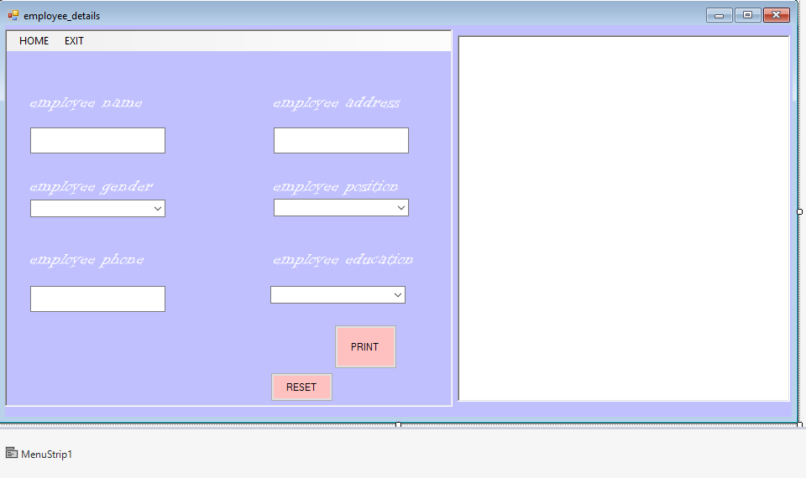

ELECTRICITY BILL SCREEN LAYOUT FORM

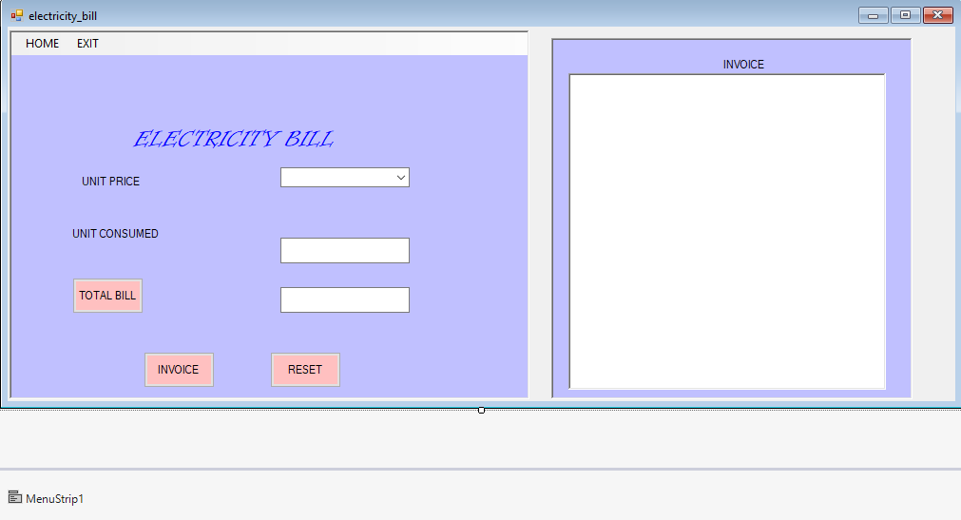

RELATIONSHIPS BETWEEN TABLES

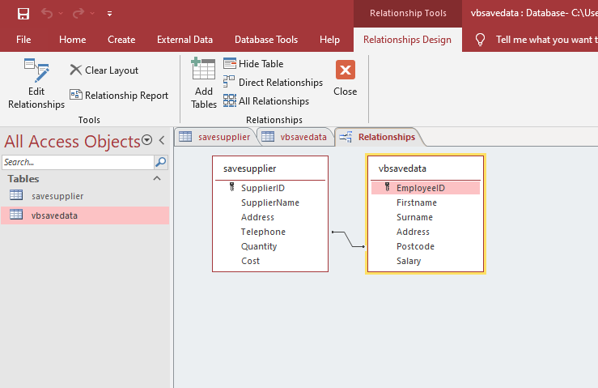

OVERAL PLAN

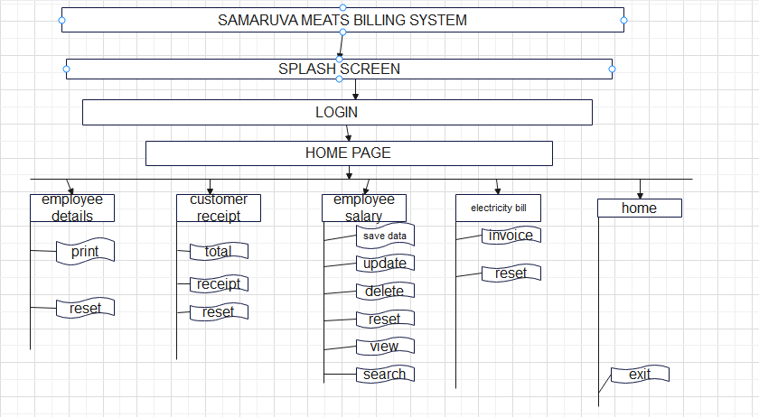

OUTPUT DESIGN

The system output has to include reports that show;

-A summary that involves the employee salary, names and their address

-Gives the total electricity bill used per period

-New suppliers and employee into the system

-Expected message box responses- which improve error detection in the running of the system

e.g.: If a wrong username or password is entered when logging in, a message written “sorry incorrect username and password” should show as shown below

EMPLOYEE SALARY

The below form shows the expected output when the user presses the button view in order to view the inputted data.

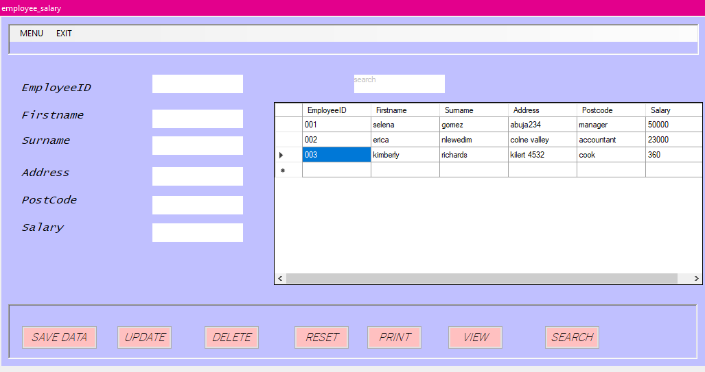

ELECTRICITY BILL

The below form shows the output that will be displayed if the user inputs the unit price and the unit consumed and it is calculated. This leads to the displaying of an invoice.

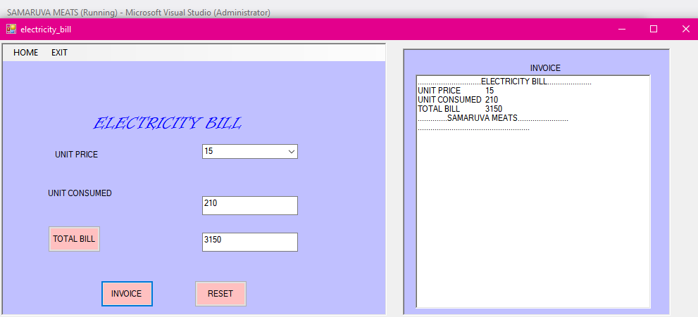

EMPLOYEE DETAILS

The following shows the output that is expected when the user presses the button labeled print in order to display the employees’ details.

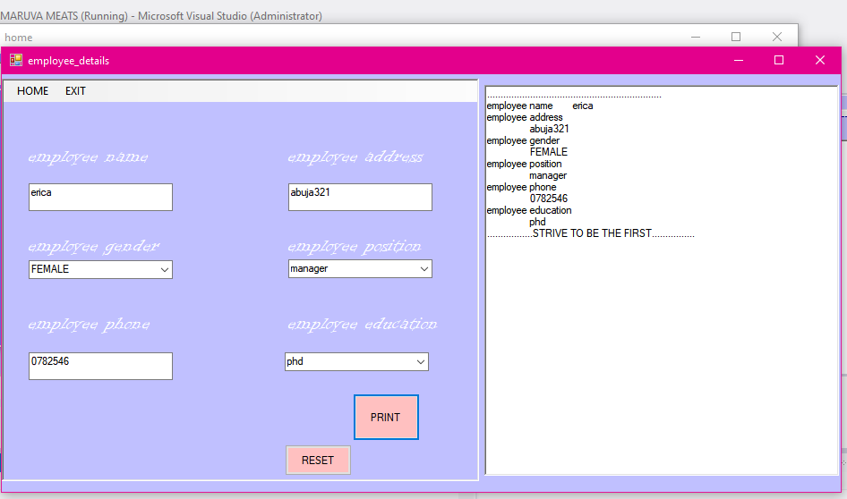

EMPLOYEE SALARY

The below screenshot shows the message that will be displayed is the has pressed the button save in order to save a specific record.

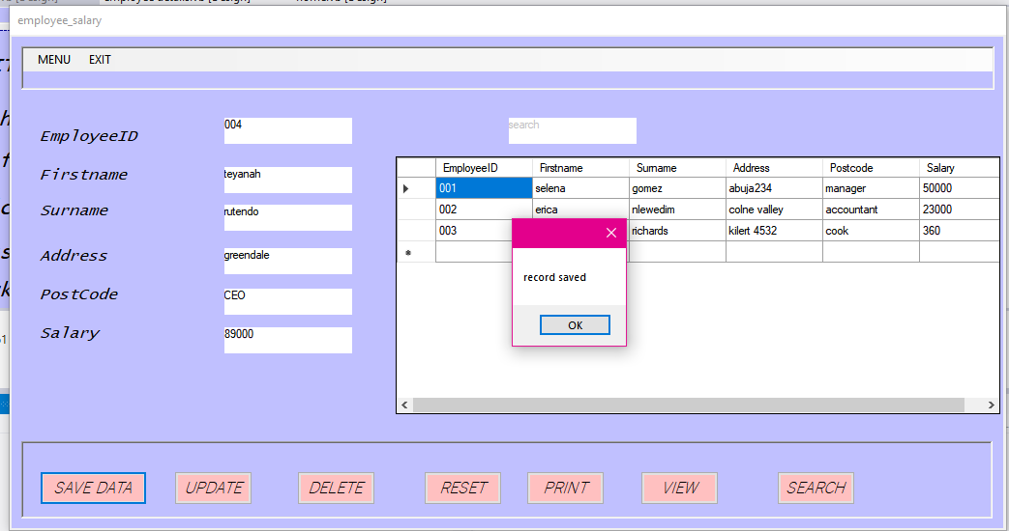

The below form shows the message that will be displayed if the user wants to update the database.

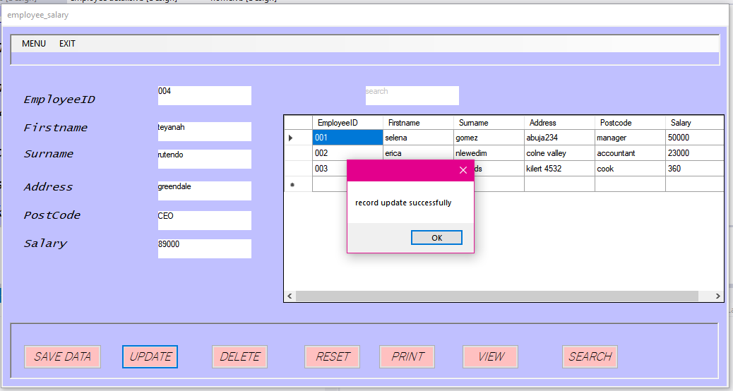

TEST PLAN

-Is a process of evaluating the system with an initiation of creating a strong and mainly focuses on the weak areas of the system or software?

-Test plan helps to design and organize the test. It gives the general idea about the schedule of testing, as well as to identify the test items for contrasting and can be done in parallel and design phase.

-It also involves the construction and assembling of the technical components that are needed for the new system to operate.

**WHITE BOX**

It is a method of testing software that tests internal structures of an application, as opposed to its functionality

ADVANTAGES

* There is transparency of internal coding structure which is helpful in driving the type of input data needed to test an application.
* The test plan covers all possible path of a code and therefore empowering through application testing.
* It enables the programmer to introspect because developers can carefully describe any new implementation.

DISADVANTAGES

* Developing test cases for white box testing involves high degree of complexity therefore it requires highly skilled people to develop the test cases.
* Change in objects name may lead to breaking of the test script.

**BLACK BOX TESTING**

It does not require knowledge of the code as needed to perform white box testing. Anyone can perform the testing to see if the system is working this will save time limit.

ADVANTAGES

* It does not require a system tester to have knowledge of the codes as needed to perform white box testing.
* If test the functionality of the system.
* Easy to use because the researcher does not have to contain himself with the coding of the application.
* It is easy and faster because the researcher only compares the expected results with the produced results.

**JUSTIFICATION OF THE TEST**

The system analyst chose to use the black box test because the testers do not require technical knowledge or IT skills. There’s a low chance of false positives. There is a decision table testing which allows good results to be produced. It is more efficient when used on large systems.

SECTION C

SOFTWARE DEVELOPMENT

This include the design, documentation, programming, testing and ongoing maintenance of the new system.at this stage the system analyst’s aims was to create a programmed software to meet the aims and objectives of the Samaruva meats butcher.

FLOWCHART FOR ADDING AN EMPLOYEE

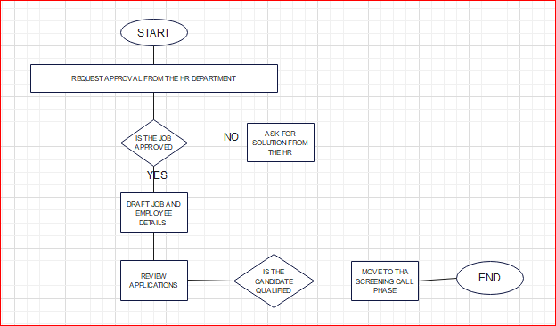

FLOWCHART FOR CALCULATING EMPLOYEE SALARY

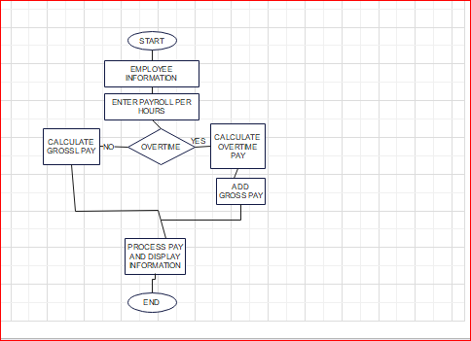

PSEUDOCODE FOR CALCULATING ELECTRICITY BILL

INPUT unit price

INPUT unit consumed

COMPUTE bill = unit price * unit consumed

DISPLAY output

PRINT total bill

PRINT invoice

CODE LISTING

CODE FOR THE SPLASH SCREEN

Public Class splash

Private Sub Timer1_Tick(sender As Object, e As EventArgs) Handles Timer1.Tick

If (ProgressBar1.Value = ProgressBar1.Maximum) Then

Timer1.Stop()

Me.Hide()

login.Show()

Else

ProgressBar1.PerformStep()

Timer1.Start()

End If

End Sub

Private Sub ProgressBar1_Click(sender As Object, e As EventArgs) Handles ProgressBar1.Click

Timer1.Start()

End Sub

End Class

CODE FOR LOGIN

Public Class login

Private Sub btnlogin_Click(sender As Object, e As EventArgs) Handles btnlogin.Click

If txtpass.Text = "admin" And txtuser.Text = "user1" Then

MsgBox("WELCOME ADMINISTRATOR!")

Me.Hide()

home.Show()

Else

MsgBox("sorry incorrect password and username", MsgBoxStyle.OkOnly, "invalid")

End If

End Sub

Private Sub btndelete_Click(sender As Object, e As EventArgs) Handles btndelete.Click

'clear all textboxes

txtpass.Clear()

txtuser.Clear()

End Sub

End Class

CODE FOR THE HOME PAGE

Public Class home

Private Sub EXITToolStripMenuItem_Click(sender As Object, e As EventArgs) Handles EXITToolStripMenuItem.Click

End

End Sub

Private Sub ELECTRICITYBILLToolStripMenuItem_Click(sender As Object, e As EventArgs) Handles ELECTRICITYBILLToolStripMenuItem.Click

electricity_bill.Show()

End Sub

Private Sub EMPLOYEEDETAILSToolStripMenuItem_Click(sender As Object, e As EventArgs) Handles EMPLOYEEDETAILSToolStripMenuItem.Click

employee_details.Show()

End Sub

Private Sub CUSTOMERRECEIPTToolStripMenuItem_Click(sender As Object, e As EventArgs) Handles CUSTOMERRECEIPTToolStripMenuItem.Click

customer_receipt.Show()

End Sub

Private Sub EMPLOYEESALARYToolStripMenuItem_Click(sender As Object, e As EventArgs) Handles EMPLOYEESALARYToolStripMenuItem.Click

employee_salary.Show()

End Sub

CODE FOR ELECTRICITY BILL

Public Class electricity_bill

Private Sub HOMEToolStripMenuItem_Click(sender As Object, e As EventArgs) Handles HOMEToolStripMenuItem.Click

'back to home page

Me.Hide()

home.Show()

End Sub

Private Sub EXITToolStripMenuItem_Click(sender As Object, e As EventArgs) Handles EXITToolStripMenuItem.Click

End

End Sub

Private Sub btninvoice_Click(sender As Object, e As EventArgs) Handles btninvoice.Click

'electricity invoice

rtinvoice.AppendText("..............................ELECTRICITY BILL....................." & vbNewLine)

rtinvoice.AppendText(lblunitprice.Text & vbTab & cboxprice.Text & vbNewLine)

rtinvoice.AppendText(lblconsumed.Text & vbTab & txtconsumed.Text & vbNewLine)

rtinvoice.AppendText(totalbill.Text & vbTab & txttotalcost.Text & vbNewLine)

rtinvoice.AppendText("..............SAMARUVA MEATS........................" & vbNewLine)

rtinvoice.AppendText(".....................................................")

End Sub

Private Sub totalbill_Click(sender As Object, e As EventArgs) Handles totalbill.Click

Dim a As Integer

Dim b As Integer

Dim c As Integer

a = cboxprice.Text

b = txtconsumed.Text

c = a * b

txttotalcost.Text = c

End Sub

Private Sub btnreset_Click(sender As Object, e As EventArgs) Handles btnreset.Click

'clear all entered information

txttotalcost.Clear()

txtconsumed.Clear()

cboxprice.Text = 0

rtinvoice.Clear()

End Sub

End Class

CODE FOR EMPLOYEE DETAILS

Public Class employee_details

Private Sub employee_details_Load(sender As Object, e As EventArgs) Handles MyBase.Load

End Sub

Private Sub HOMEToolStripMenuItem_Click(sender As Object, e As EventArgs) Handles HOMEToolStripMenuItem.Click

'back to home page

Me.Hide()

home.Show()

End Sub

Private Sub btnprint_Click(sender As Object, e As EventArgs) Handles btnprint.Click

'display all the inputed information

rtdetails.AppendText("................................................................." & vbNewLine)

rtdetails.AppendText(lblname.Text & vbTab & txtname.Text & vbTab & vbNewLine)

rtdetails.AppendText(lbladdress.Text & vbTab & txtaddress.Text & vbTab & vbNewLine)

rtdetails.AppendText(lblgender.Text & vbTab & cboxgender.Text & vbTab & vbNewLine)

rtdetails.AppendText(lblposition.Text & vbTab & cboxposition.Text & vbTab & vbNewLine)

rtdetails.AppendText(lblphone.Text & vbTab & txtphone.Text & vbTab & vbNewLine)

rtdetails.AppendText(lbleducation.Text & vbTab & cboxeducation.Text & vbTab & vbNewLine)

rtdetails.AppendText(".................STRIVE TO BE THE FIRST................")

End Sub

Private Sub btnreset_Click(sender As Object, e As EventArgs) Handles btnreset.Click

'clear all entered information

txtname.Clear()

txtaddress.Clear()

txtphone.Clear()

rtdetails.Clear()

End Sub

Private Sub EXITToolStripMenuItem_Click(sender As Object, e As EventArgs) Handles EXITToolStripMenuItem.Click

End

End Sub

End Class

CODE FOR EMPLOYEE SALARY

Public Class employee_salary

Dim conn As New OleDb.OleDbConnection

Dim cmd As OleDb.OleDbCommand

Dim dt As New DataTable

Dim da As New OleDb.OleDbDataAdapter(cmd)

Private bitmap As Bitmap

Private Sub viewer()

conn.Open()

cmd = conn.CreateCommand

cmd.CommandType = CommandType.Text

da = New OleDb.OleDbDataAdapter("select * from vbsavedata", conn)

da.Fill(dt)

DataGridView1.DataSource = dt

conn.Close()

End Sub

Private Sub employee_salary_Load(sender As Object, e As EventArgs) Handles MyBase.Load

'connect vb to database

conn.ConnectionString = "Provider=Microsoft.ACE.OLEDB.12.0;Data Source=C:\Users\wendywekare\Documents\vbsavedata.accdb"

txtsearch.Text = "search"

txtsearch.ForeColor = Color.Silver

viewer()

End Sub

Private Sub Label7_Click(sender As Object, e As EventArgs) Handles lbladdress.Click

End Sub

Private Sub TextBox1_TextChanged(sender As Object, e As EventArgs) Handles txtemployeeid.TextChanged

End Sub

Private Sub Panel1_Paint(sender As Object, e As PaintEventArgs) Handles Panel1.Paint

End Sub

Private Sub btnsavedata_Click(sender As Object, e As EventArgs) Handles btnsavedata.Click

Try

conn.Open()

cmd = conn.CreateCommand

cmd.CommandType = CommandType.Text

cmd.CommandText = " insert into vbsavedata (EmployeeID,Firstname,Surname,Address,Postcode,Salary)values ('" + txtemployeeid.Text + "','" + txtname.Text + "','" + txtsurname.Text + "','" + txtaddress.Text + "','" + txtpostcode.Text + "','" + txtsalary.Text + "')"

cmd.ExecuteNonQuery()

conn.Close()

MessageBox.Show("record saved")

Catch ex As Exception

MessageBox.Show(ex.Message, "vbsavedatabase", MessageBoxButtons.OK, MessageBoxIcon.Error)

conn.Close()

End Try

End Sub

Private Sub MENUToolStripMenuItem_Click(sender As Object, e As EventArgs) Handles MENUToolStripMenuItem.Click

Me.Hide()

home.Show()

End Sub

Private Sub EXITToolStripMenuItem_Click(sender As Object, e As EventArgs) Handles EXITToolStripMenuItem.Click

End

End Sub

Private Sub btnupdate_Click(sender As Object, e As EventArgs) Handles btnupdate.Click

Try

conn.Open()

cmd = conn.CreateCommand

cmd.CommandType = CommandType.Text

cmd.CommandText = " update vbsavedata set EmployeeID ='" + txtemployeeid.Text + "'where Firstname ='" + txtname.Text + "'and Surname = '" + txtsurname.Text + "' "

cmd.ExecuteNonQuery()

conn.Close()

MessageBox.Show("record update successfully")

btnsearch_Click(New Object, New EventArgs())

viewer()

Catch ex As Exception

MessageBox.Show(ex.Message, "vbsavedatabase", MessageBoxButtons.OK, MessageBoxIcon.Error)

End Try

End Sub

Private Sub Label1_Click(sender As Object, e As EventArgs)

End Sub

Private Sub DataGridView1_CellClick(sender As Object, e As DataGridViewCellEventArgs) Handles DataGridView1.CellClick

'

Try

txtemployeeid.Text = DataGridView1.SelectedRows(0).Cells(0).Value.ToString()

txtname.Text = DataGridView1.SelectedRows(0).Cells(1).Value.ToString()

txtsurname.Text = DataGridView1.SelectedRows(0).Cells(2).Value.ToString()

txtaddress.Text = DataGridView1.SelectedRows(0).Cells(3).Value.ToString()

txtpostcode.Text = DataGridView1.SelectedRows(0).Cells(4).Value.ToString()

txtsalary.Text = DataGridView1.SelectedRows(0).Cells(5).Value.ToString()

Catch ex As Exception

MessageBox.Show(ex.Message, "vbsavedatabase", MessageBoxButtons.OK, MessageBoxIcon.Error)

conn.Close()

End Try

End Sub

Private Sub btnsearch_Click(sender As Object, e As EventArgs) Handles btnsearch.Click

'search employee

Dim checker As Integer

Try

conn.Open()

cmd = conn.CreateCommand

cmd.CommandType = CommandType.Text

cmd.CommandText = " select * from vbsavedata where EmployeeID ='" + txtemployeeid.Text + "'or Firstname ='" + txtname.Text + "'or Surname = '" + txtsurname.Text + "' "

cmd.ExecuteNonQuery()

dt = New DataTable()

da = New OleDb.OleDbDataAdapter(cmd)

da.Fill(dt)

checker = Convert.ToInt32(dt.Rows.Count.ToString)

DataGridView1.DataSource = dt

conn.Close()

If (checker = 0) Then

MessageBox.Show("record update successfull")

txtsearch.Text = "Search"

End If

Catch ex As Exception

MessageBox.Show(ex.Message, "vbsavedatabase", MessageBoxButtons.OK, MessageBoxIcon.Error)

conn.Close()

End Try

End Sub

Private Sub btndelete_Click(sender As Object, e As EventArgs) Handles btndelete.Click

'delete employee

Try

conn.Open()

cmd = conn.CreateCommand

cmd.CommandType = CommandType.Text

cmd.CommandText = " delete * from vbsavedata where EmployeeID ='" + txtemployeeid.Text + "'where Firstname ='" + txtname.Text + "'and Surname = '" + txtsurname.Text + "' "

cmd.ExecuteNonQuery()

conn.Close()

MessageBox.Show("record deleted successfully")

btnsearch_Click(New Object, New EventArgs())

viewer()

txtemployeeid.Text = ""

txtname.Text = ""

txtsurname.Text = ""

txtaddress.Text = ""

txtpostcode.Text = ""

txtsalary.Text = ""

txtsearch.Text = "Search"

Catch ex As Exception

MessageBox.Show(ex.Message, "vbsavedatabase", MessageBoxButtons.OK, MessageBoxIcon.Error)

conn.Close()

End Try

End Sub

Private Sub btnreset_Click(sender As Object, e As EventArgs) Handles btnreset.Click

txtemployeeid.Text = ""

txtname.Text = ""

txtsurname.Text = ""

txtaddress.Text = ""

txtpostcode.Text = ""

txtsalary.Text = ""

txtsearch.Text = "Search"

End Sub

CODE FOR CUSTOMER RECEIPT

Public Class customer_receipt

'sub routine declaration

Const fish_price = 0.3

Const beefperkg_price = 2.5

Const chickenperkg_price = 1.5

Const sausagesperkg_price = 3.75

Const porkperkg_price = 2.05

Dim items(9)

Private Sub Panel3_Paint(sender As Object, e As PaintEventArgs) Handles Panel3.Paint

End Sub

Private Sub HOMEToolStripMenuItem_Click(sender As Object, e As EventArgs) Handles HOMEToolStripMenuItem.Click

Me.Hide()

home.Show()

End Sub

Private Sub EXITToolStripMenuItem_Click(sender As Object, e As EventArgs) Handles EXITToolStripMenuItem.Click

End

End Sub

Private Sub Button2_Click(sender As Object, e As EventArgs) Handles btnreceipt.Click

'sub routine call

rtreceipt.AppendText("............SAMARUVA MEATS...................................................................")

rtreceipt.AppendText(lblfish.Text & vbTab & numfish.Value & vbTab & txtfish.Text & vbNewLine)

rtreceipt.AppendText(lblbeef.Text & vbTab & numbeef.Value & vbTab & txtbeef.Text & vbNewLine)

rtreceipt.AppendText(lblchicken.Text & vbTab & numchicken.Value & vbTab & txtchicken.Text & vbNewLine)

rtreceipt.AppendText(lblsausage.Text & vbTab & numsausages.Value & vbTab & txtsausages.Text & vbNewLine)

rtreceipt.AppendText(lblpork.Text & vbTab & numpork.Value & vbTab & txtpork.Text & vbNewLine)

rtreceipt.AppendText(lbltotalcost.Text & vbTab & vbTab & txttotalcost.Text & vbNewLine)

rtreceipt.AppendText("....................................................................................")

rtreceipt.AppendText(".........................THANK YOU .................................................")

End Sub

Private Sub Panel1_Paint(sender As Object, e As PaintEventArgs) Handles Panel1.Paint

End Sub

Private Sub customer_receipt_Load(sender As Object, e As EventArgs) Handles MyBase.Load

End Sub

Private Sub numfish_SelectedIndexChanged(sender As Object, e As EventArgs)

End Sub

Private Sub numbeef_SelectedIndexChanged(sender As Object, e As EventArgs)

End Sub

Private Sub numfish_ValueChanged(sender As Object, e As EventArgs) Handles numfish.ValueChanged

txtfish.Text = FormatCurrency(numfish.Value * fish_price)

End Sub

Private Sub numbeef_ValueChanged(sender As Object, e As EventArgs) Handles numbeef.ValueChanged

txtbeef.Text = FormatCurrency(numbeef.Value * beefperkg_price)

End Sub

Private Sub numchicken_ValueChanged(sender As Object, e As EventArgs) Handles numchicken.ValueChanged

txtchicken.Text = FormatCurrency(numchicken.Value * chickenperkg_price)

End Sub

Private Sub numsausages_ValueChanged(sender As Object, e As EventArgs) Handles numsausages.ValueChanged

txtsausages.Text = FormatCurrency(numsausages.Value * sausagesperkg_price)

End Sub

Private Sub numpork_ValueChanged(sender As Object, e As EventArgs) Handles numpork.ValueChanged

txtpork.Text = FormatCurrency(numpork.Value * porkperkg_price)

End Sub

Private Sub btntotal_Click(sender As Object, e As EventArgs) Handles btntotal.Click

' displaying total amount of kilograms bought

items(1) = numfish.Value * fish_price

items(2) = numbeef.Value * beefperkg_price

items(3) = numchicken.Value * beefperkg_price

items(4) = numsausages.Value * sausagesperkg_price

items(5) = numpork.Value * porkperkg_price

items(6) = items(1) + items(2) + items(3) + items(4) + items(5)

txttotalcost.Text = (items(6))

End Sub

Private Sub btnreset_Click(sender As Object, e As EventArgs) Handles btnreset.Click

'clear all entered information

numfish.Value = 0

numbeef.Value = 0

numchicken.Value = 0

numsausages.Value = 0

numpork.Value = 0

txtbeef.Text = "$0.00"

txtbeef.Text = "$0.00"

txtsausages.Text = "$0.00"

txtchicken.Text = "$0.00"

txtpork.Text = "$0.00"

txttotalcost.Text = "$0.00"

rtreceipt.Clear()

End Sub

End Class

USER DOCUMENTATION

INSTALLATION

1. Insert the disk of the system into the computer disk drive.
2. Click on “This PC” and open the disk drive.
3. Copy the files in the installation disk to the desktop.
4. Open the copied folder named “SAMARUVA MEATS ” and open setup You have to follow the instructions that will be displayed on the screen.
5. Once the installation is done the system will be ready for use.

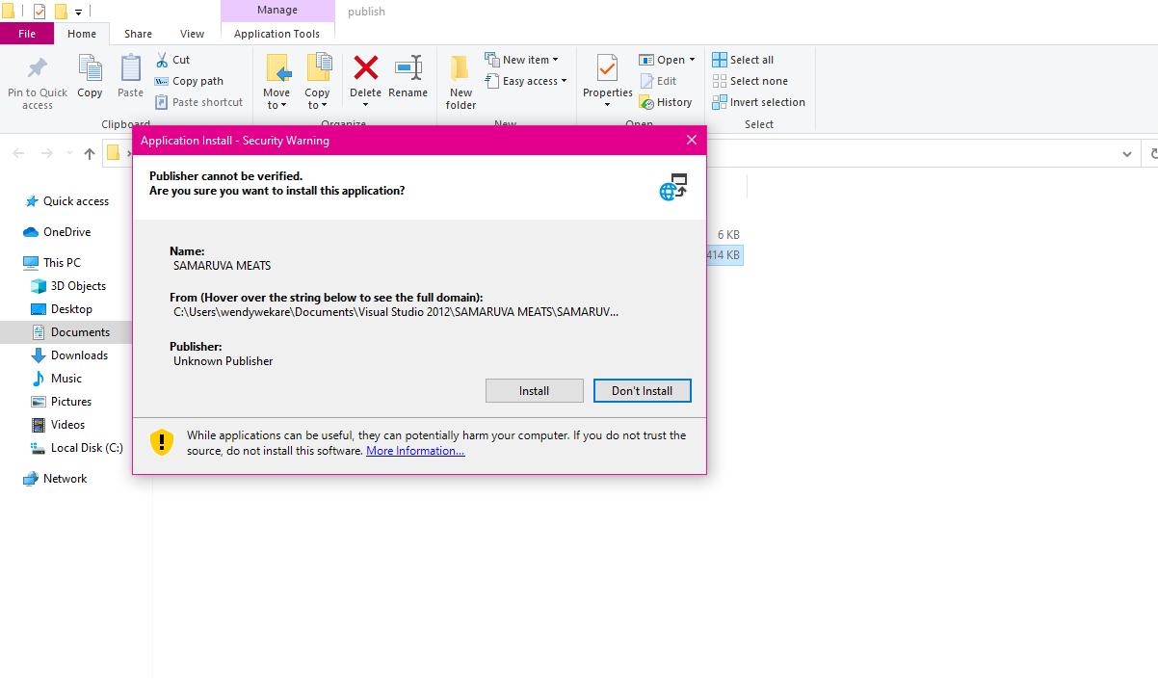

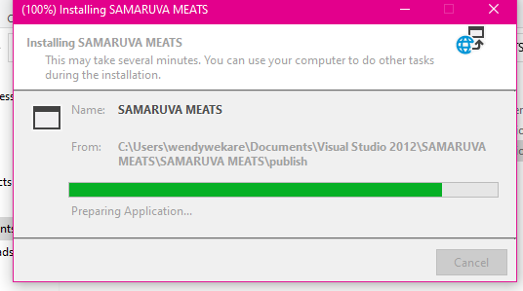

RUNNING THE SYSTEM

1. Click on the file named “SAMARUVA MEATS” Press the start button on top of the windows application form.
2. A splash screen will be displayed and the after the splash screen has loaded
3. Enter the username “user1” and the password “admin”
4. The following form will be displayed that is the home form

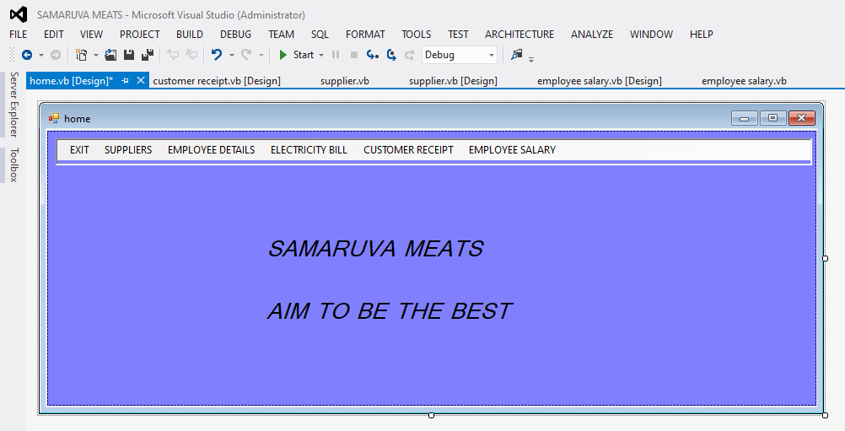

NAVIGATION OF THE SYSTEM

When the user wants to print out the customer receipt the first thing to do is to input the product bought by the customer and the quantity.

Press the receipt button as shown in the below form. The receipt will be displayed as in the form below.

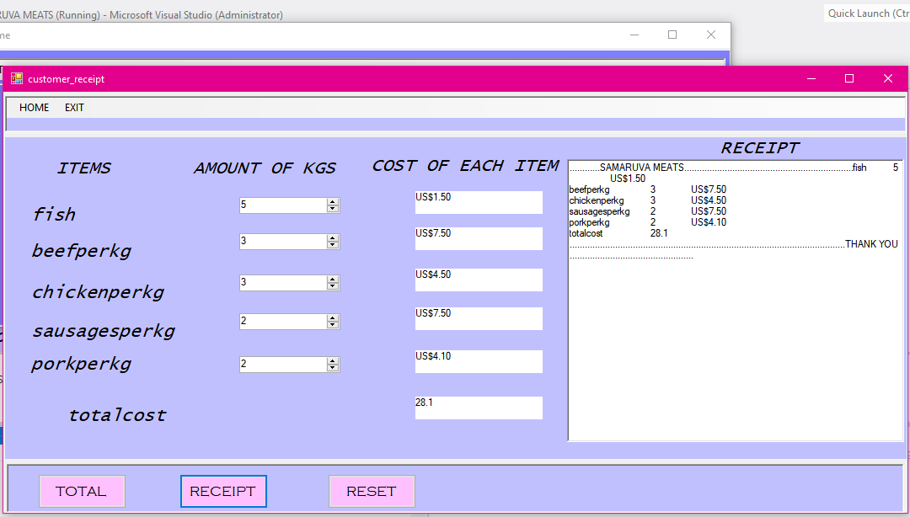

When the user wants to display the invoice of the electricity bill the first step is to input the unit consumed and the unit price.

Press the total button that will display the total price of the electricity bill and press the invoice button to display the details.



When the user wants to display the employee details after they input the details of a specific employee. Press the button print to display the details.



EXITING THE SYSTEM

If the user wants to exit the exit the system the following message will be displayed by the system to confirm if the user is sure if they want to exit

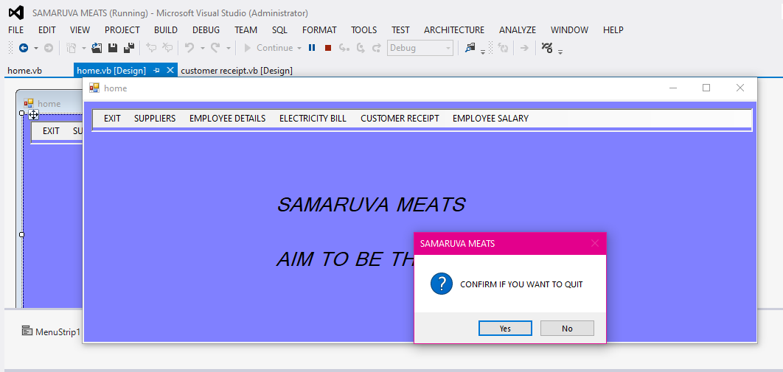

SECTION D

TESTING AND EVALUATION

This is the process by which the system analyst compares system components against requirements through testing. The results are evaluated to assess progress, performance and stability of the designed system.

USER TESTING

It is an effective method of identifying design error at an early stage in development, when system functionalities are still in basic form, or not yet implemented.

TEST FOR STANDARD DATA



TEST FOR EXTREME DATA

Testing is important because computer software is usually very complex, usually software is tested with three distinct types of data: Typical data is normal data the system should be working with. Extreme data is data at the boundary between typical data and invalid data.

At this stage the system analyst was testing if for instance the receipt form is working for examples in the process of inputting the number of kilograms that a customer what to buy.

This is how the form is to appear like the below picture

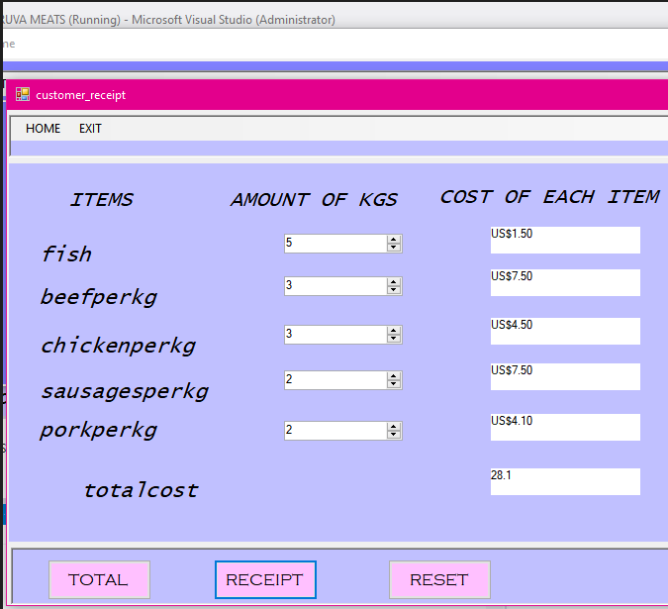As shown in the above form the cost of each depends on the amount of kilograms that each customer is buying.

The receipt should also display the items bought by the customer when the user presses the button receipt.



TEST FOR INVALID / ABNORMAL DATA

Invalid data is data that should not be accepted by the system. Abnormal values are used in testing to make sure that invalid data does not break the system.

If the user is to enter incorrect or invalid data into the system the following are some of the messages indicating that there’s invalid data:

The form below shows the message that will be displayed by the user is to input the wrong username and password

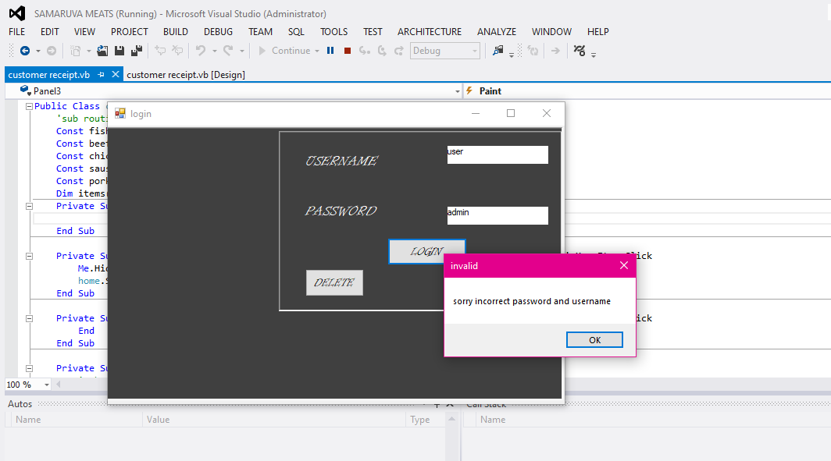

INVALID DATA

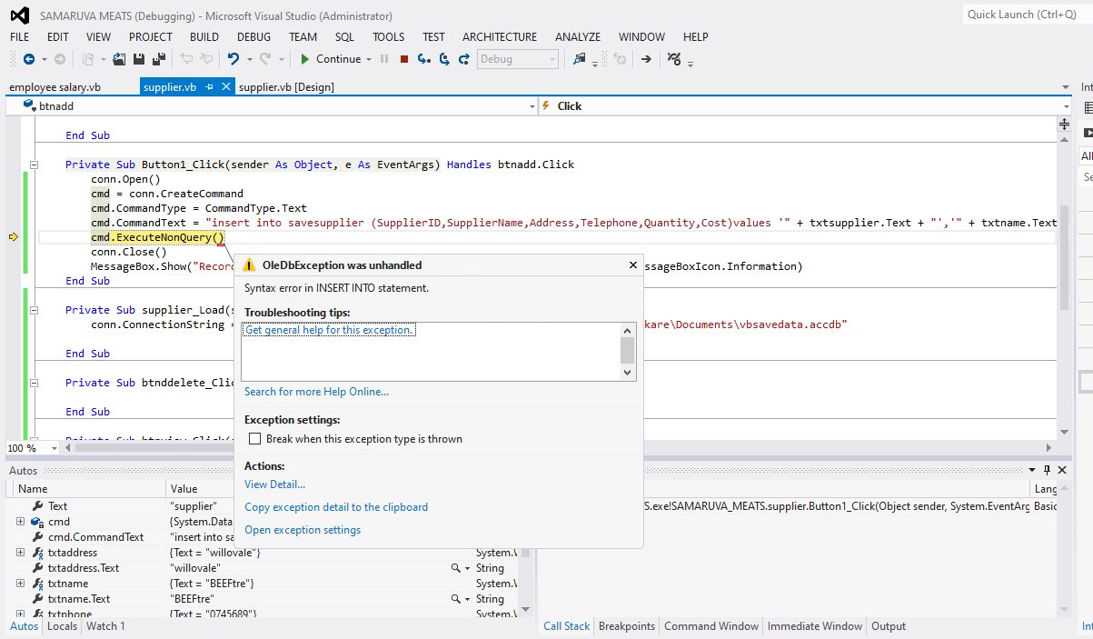

The below form shows an example of a sample run of the receipt form if it displays or prints the items bought by the customer.



The below form shows the message that will be displayed by the system if the user inputs data that breaks the system. This is the error message that will be displayed by system.



SYSTEM TESTING

EASE OF USE

-Instructions on using the system are very clear that the user can understand, system documentation explains how to use the system.

Reliability

-The system was coded with no errors therefore also it produces reliable results if details are supposed it saves if not it will not save and it gives messages to notify.

Effectiveness

-The system works efficiently and produces results with minimum delay. The system analyst   measured its ability to perform the functions necessary to achieve goals or objectives, defined as the product of the number of combinations of behavior to reach function of each combination.

EVALUATION OF LIMITATIONS OF THE SYSTEM

System evaluation includes measuring the final system against its initial performance goals as well as performing ongoing testing to see that the system continues to meet those goals. The system analyst made sure that the objectives were met below are some of the achievements:

ARCHIVEMENTS OF THE SYSTEM

- After the evaluation, the system analyst looked at the objectives, that is the initial user requirements and quite a number were fulfilled. The following are the achievements met on the new system.

-It can notify user if user enters incorrect data.

-The system allows input of data into the database.

-Allows update, deletion, saving and further manipulation of data in the database.

-Is able to calculate current kilograms in stock and whether the company is making profit or loss.

LIMITATIONS OF THE SYSTEM

The system analyst did try to produce a perfect system that could meet the aims and objectives of the business. The following are the limitations the system analyst found about the system.

-The system has limited access to specific users.

-It is not linked to the internet because of lesser resource availability like capital.

-The system can only operate on Microsoft windows and is not compatible with other OS

OPPORTUNITTIES FOR FUTURE DEVELOPMENT

-Its effectiveness can improve if connected to the internet.

-The system could use an added module for multiple user access to improve effectiveness of the system.

-It could be improved by having it linked with a point-of-sale system for quicker manipulation of event.